**Climate Resilience in Agriculture**

**Overview**

The dataset contains key variables describing various aspects of climate change, such as adaptation strategies, average temperature anomaly, CO2 emissions (total), crop yield anomalies (base years 2008–2015), economic impact and extreme weather events in multiple countries/regions. This enables me to monitor trends in productivity, environmental sustainability, and economic outcomes caused by climate change's impact on agriculture.

**Objective**

* Analyse the influence of temperature and precipitation as covariates on factors like CO2 emissions and climate risk.
* Assess how climate risk affects crop yields and financial stability in agriculture.
* Characterize the impact of successful adaptation technologies such as irrigation access and fertiliser use.
* Develop a dashboard to visualise the relationships between temperature, precipitation, emissions, crop yields, financial stability, and adaptation technologies, enabling data-driven decision-making for sustainable agriculture.

**1-Data Cleaning**   
In order to prepare raw data for analysis, data cleaning involves finding missing values for important variables like temperature and crop yields. This can be done by adding missing data points or by deleting incomplete data points. It involves removing redundant records to maintain accuracy, adjusting data types to guarantee consistency (for example, confirming that "Year" is a number), and spotting anomalies that could skew the findings. Furthermore, standardization guarantees consistency in measurement units (turning all precipitation data to millimetres, for example), producing a clean, dependable dataset for precise analysis.

**2-Data Exploration and Analysis**Involves using exploratory data analysis (EDA) to find correlations, trends, and patterns in the dataset. This step focuses on variables like temperature, precipitation, CO2 emissions, and crop yields to get insights into how climate conditions influence agricultural outcomes. EDA helps to direct further analysis and building models by displaying the data using charts and graphs, finding relationships, and spotting irregularities. Getting an improved understanding of the data and its main drivers is the goal before moving on to more complex statistical or predictive studies.

**3-Normalization**

The process of organizing data to reduce duplication while improving integrity is known as normalization. Significant steps were taken:  
  
**1-Eliminating Duplicates**: It makes sure every record is unique and eliminates skewed analysis by removing data points that are repeated, such as weather events or crop yields.  
  
**2-Reducing Data Dependency**: By organizing data into separate tables, one can reduce unnecessary dependencies between variables. It makes it possible to perform flexible analysis without the intervention of factors like crop kind and nation.  
  
**3-Eliminating Redundancy**: Repeated data, like nation names, can be aggregated to save store space and avoid errors when modifications are made.  
  
**4-Improving Data Integrity**: Enforcing data rules, such as the prohibition of null values for important variables like temperature and agricultural yields, improves data integrity and ensures correctness and consistency.  
  
**5-Creating Relationships:** Building Relationships: Establishes connections between similar datasets (such as crop type and yield or environmental conditions) to allow for in-depth analysis without repetition.  
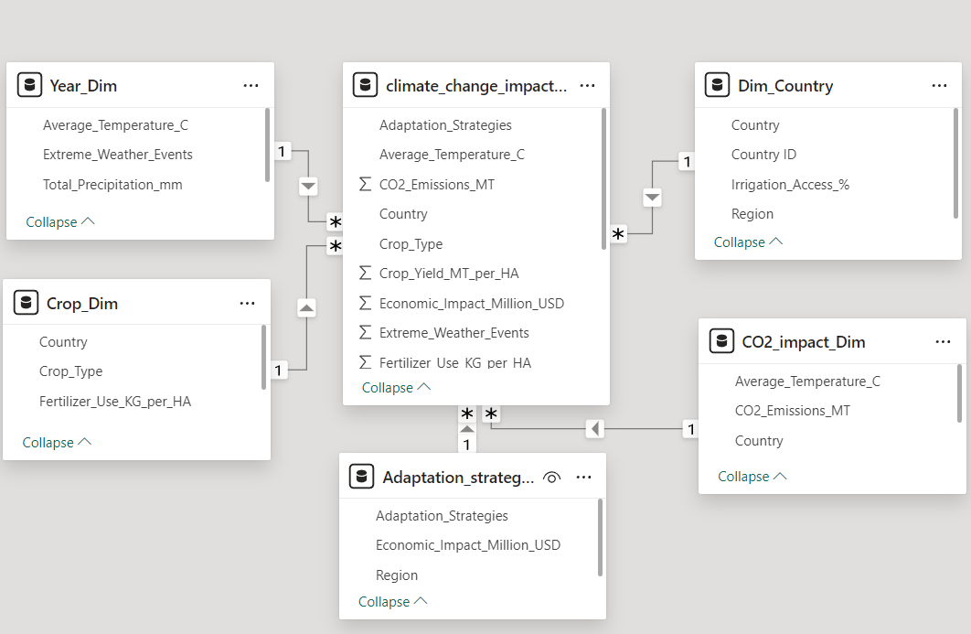

**4-Dashboard Development**

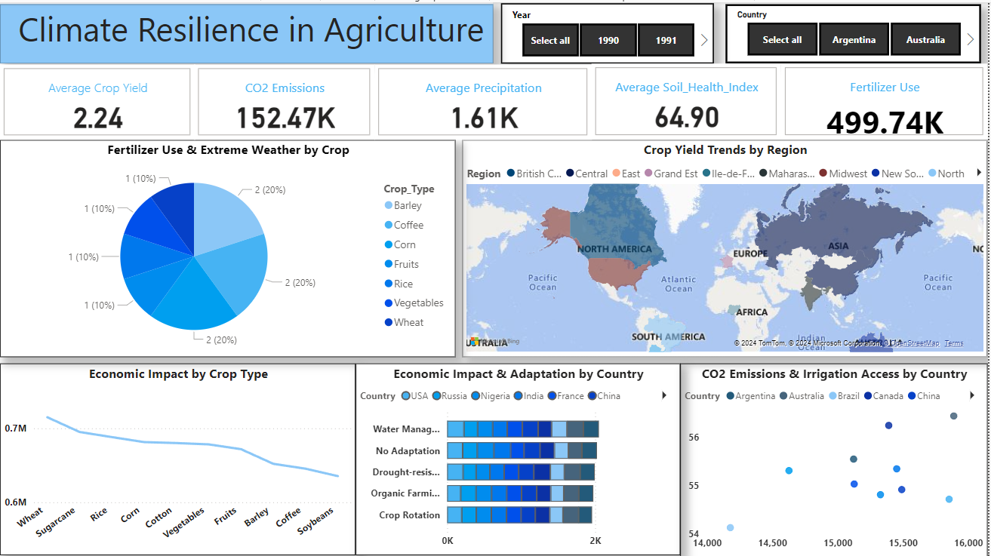To show the relationships between climatic parameters (such as temperature and CO2 emissions), strategies for adaptation (such as irrigation and fertilizer use), and agricultural outcomes (such as crop yields), create a Power BI dashboard. To demonstrate connections and the importance of climate concerns, use interactive charts. The dashboard will assist in making decisions, monitor adaption tactics, and assist in forecasting future developments in sustainable agriculture**.**